**KISHAN - The Farmers App**

***Re-Defining Crop Selling***

**Project Abstract**

**Version 1.0**

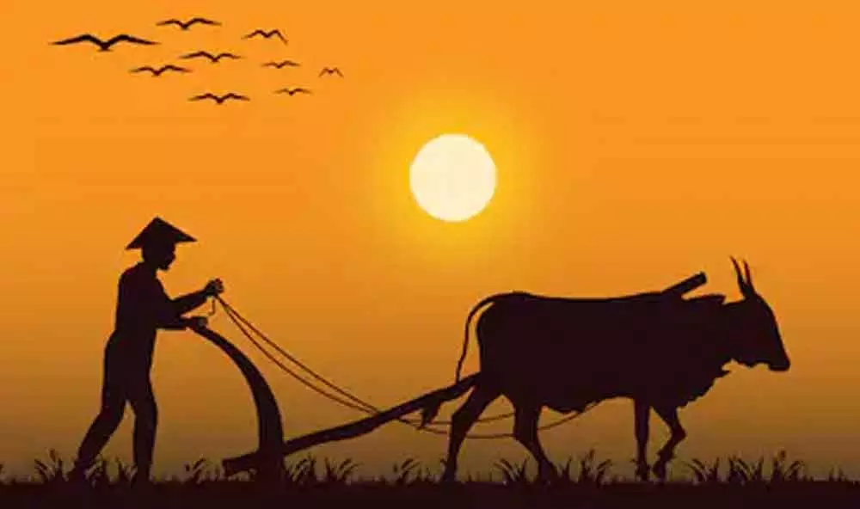

|  |  |  |  |  |
| --- | --- | --- | --- | --- |
|  | Prepared By / Last  Updated By | Mentors | Reviewed by | Approved By |
| Name | * Macha Lokeshwari | Rkrishnarjun Rao | Sharath Kumar | Sharath Kumar |
|  | * Utha Shashank | Hitesh Arora |
|  | * Gadam Bhavani | Abe Eapen Abraham |
| Role | POD Leader  POD Member  POD Member |  |  |  |
| Signature |  |  |  |  |
| Date | 02-02-2023 |  |  |  |

Table of Contents

1.0 Purpose of this document 5

2.0 Business Case 5

2.1 Project overview 5

2.2 Project Description 5

2.3 Requirements 5

2.4 Schematic Diagram 6

2.5 Project Modules 7

2.5.1 Module 1: Farmer Registration 7

2.5.2 Module 2: Farmer Updation 8

2.5.3 Module 3: Get Farmer Details 9

2.5.4 Module 4: Add Product with Farmer ID 10

2.5.5 Module 5: Get Product details with Farmer ID 11

2.5.6 Module 6: Delete Farmer Details 12

2.5.7 Module 7: Update Product Details 13

2.5.8 Module 8: Get All Products 14

2.5.9 Module 9: Get Product by Product ID 15

2.5.10 Module 10: Delete Product by Product ID 16

2.5.11 Module 11: Customer Registration 17

2.5.12 Module 12: Update Customer Details 18

2.5.13 Module 13: Get All Products from Customer Side(Feign Client) 19

2.5.14 Module 14: Get Product by Product ID from Customer Side(Feign Client) 20

2.5.15 Module 15: Get All Customer Details 21

2.5.16 Module 16: Get Customer Details by customer ID 22

2.5.17 Module 17: Get Farmer Details from customer by farmer ID (Feign Client) 23

2.5.18 Module 18: Get Farmer Details from customer by farmer ID (Feign Client) 24

2.5.19 Module 19: Add to Cart 25

2.5.20 Module 20: Remove from Cart 26

2.5.21 Module 21: View Cart 27

2.5.22 Module 22: Delete Customer using Customer ID 28

2.6 Benefits 29

3.0 Appendices 29

3.1 Glossary 29

3.2 Other 30

4.0 Terms & Conditions 30

5.0 Change Log 30

# Purpose of this document

This document provides an overview about the business need and the solution that can be provided to fulfil the objective.

# Business Case

## Project overview

Kishan Application is a computerized system used to store and retrieve information and conduct transactions related travel. The project is aimed at eliminating the 3rd party vendors and other intermediaries for the farmers to sell their goods to the buyers. It is projected towards enhancing the relationship between customers and farmers, and thereby making it convenient for the customers to get the needed goods as when they require such that they can utilize this software.

## Project Description

The system allows the customer to search for products posted by the farmers and those are available between the farmers. The system displays all the product details such as product name, organic product, price, stock availability and the farmers details etc. After search the system display list of available products and allows customer to choose products. Then the system adds those products to the cart. The customers can view the products that they have added in the cart. Once the payment is done by the customer, the farmers will send the products directly to the customers.

## Requirements

Hardware Requirements:

* Developer Laptop with 16GB RAM

Software Requirements:

* IntelliJ IDE
* Maven
* JDK
* Spring Boot
* MYSQL

## Schematic Diagram

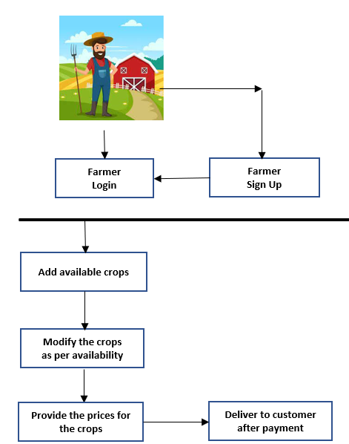

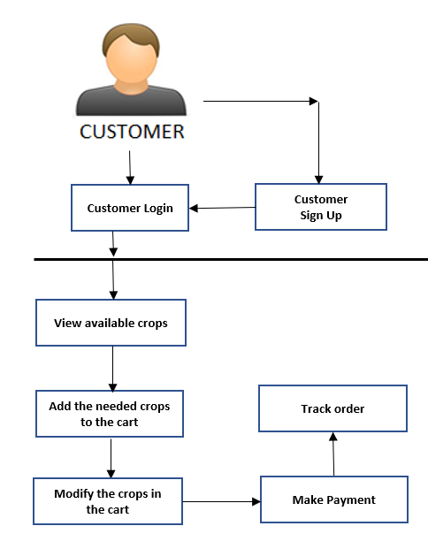

## Project Modules

### Module 1: Farmer Registration

**Source:**

<http://localhost:4001/farmer/registerFarmer>

**Request:**

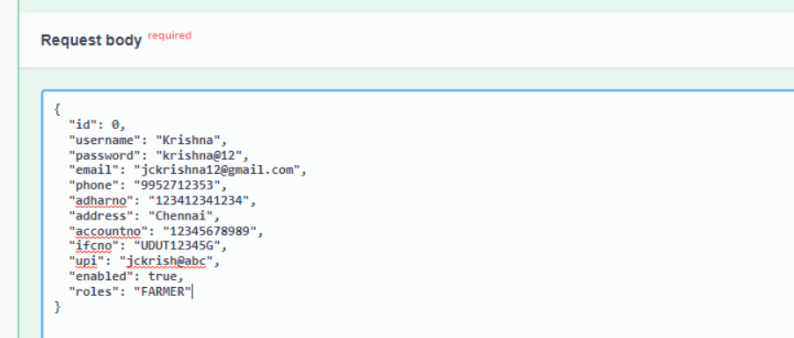

**Response:**

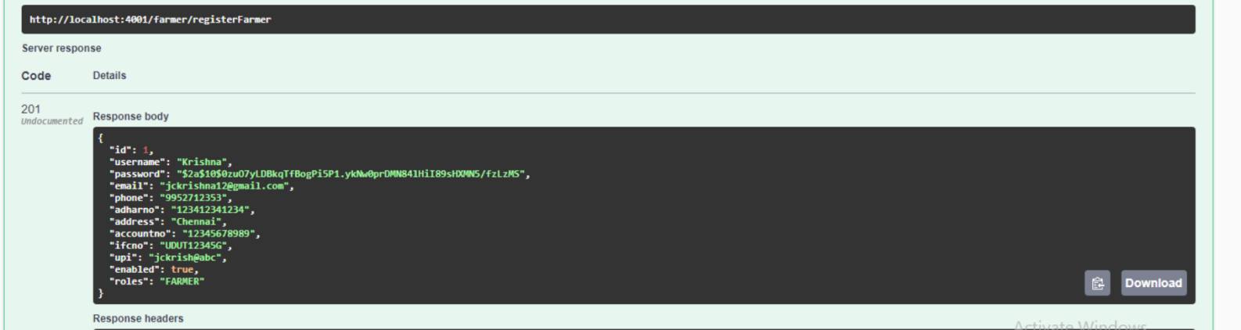

**Mailing Service:**

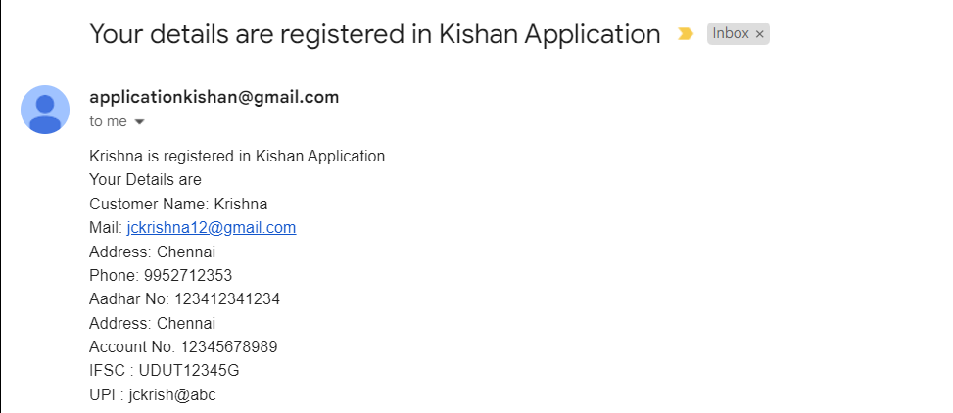

### Module 2: Farmer Updation

**Source:**

<http://localhost:4001/farmer/updatefarmer/1>

**Request:**

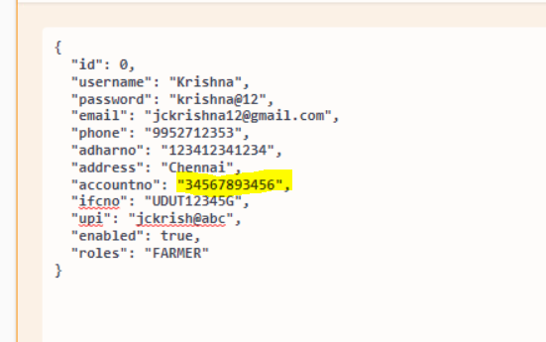

**Response:**

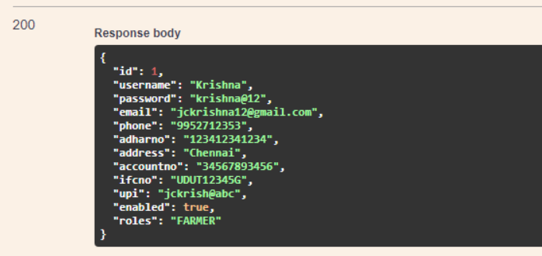

Mailing Service

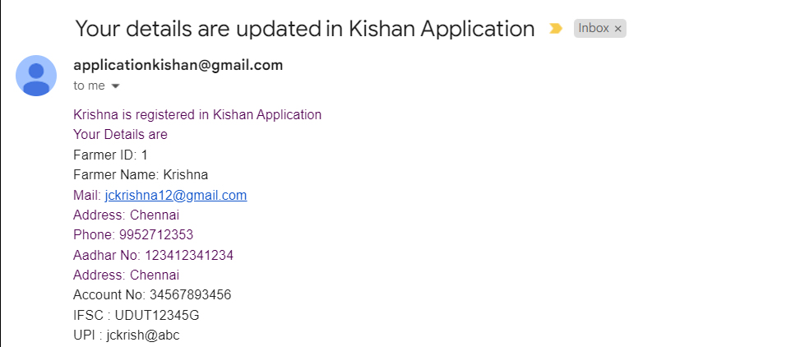

### Module 3: Get Farmer Details

**Source:**

<http://localhost:4001/farmer/getfarmerById/1>

**Request:**

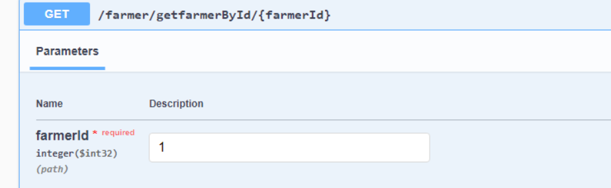

**Response:**

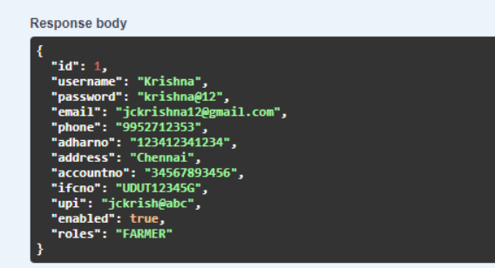

### Module 4: Add Product with Farmer ID

**Source:**

<http://localhost:4001/product/submitproduct/1>

**Request:**

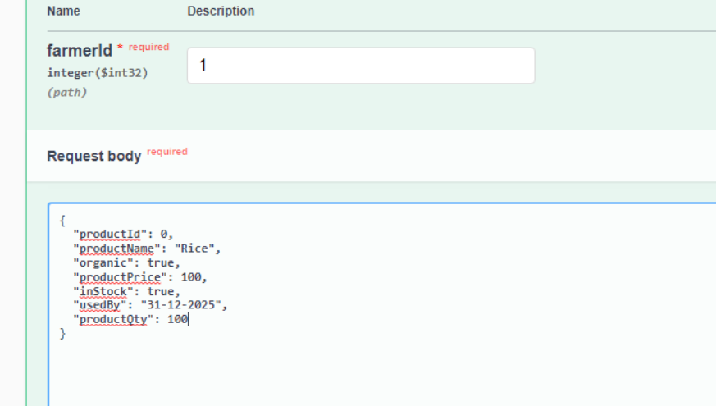

**Response:**

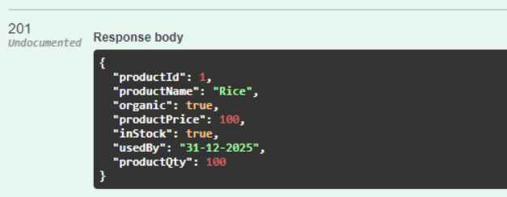

Mailing Service

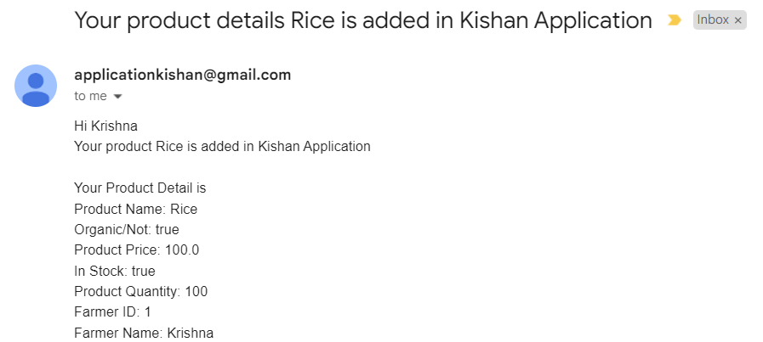

### Module 5: Get Product details with Farmer ID

**Source:**

<http://localhost:4001/farmer/getProductdetails/1>

**Request:**

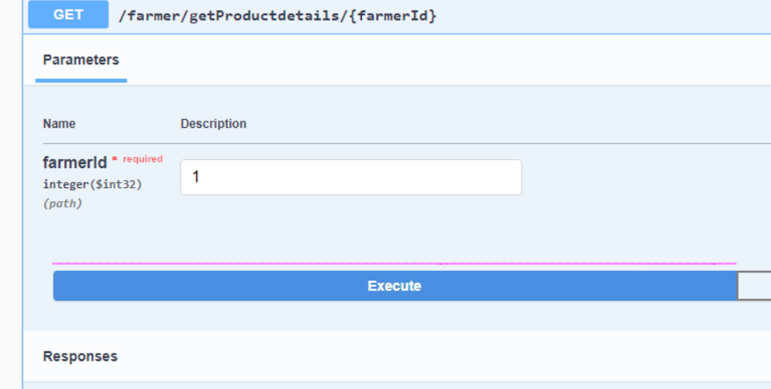

**Response:**

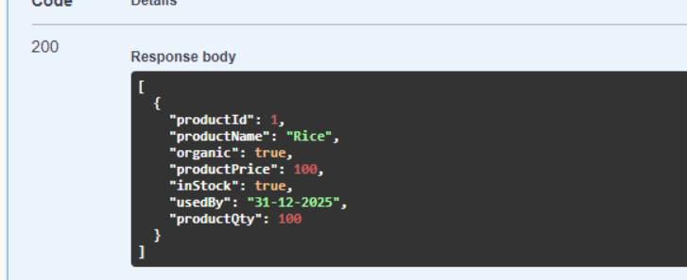

### Module 6: Delete Farmer Details

**Source:**

<http://localhost:4001/farmer/deletefarmer/2>

**Request:**

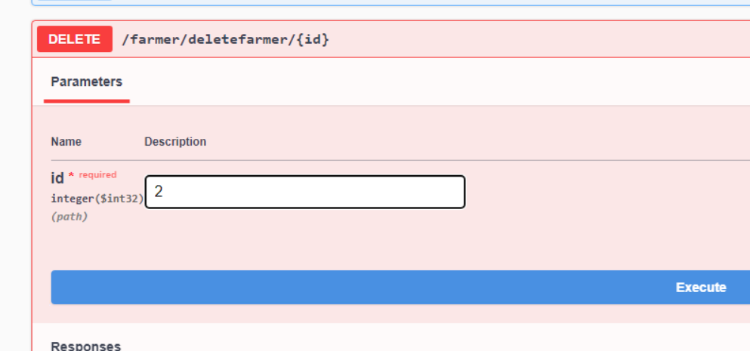

**Response:**

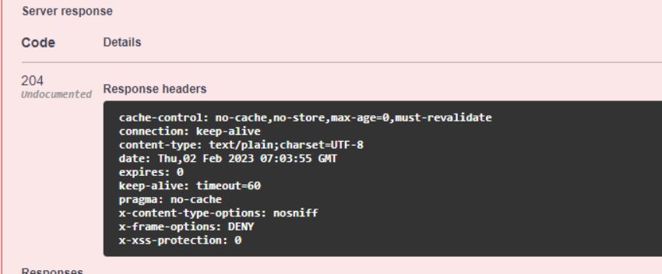

Mailing Service

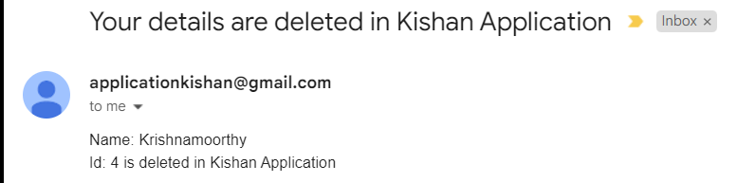

### Module 7: Update Product Details

**Source:**

<http://localhost:4001/product/updateProduct/1>

**Request:**

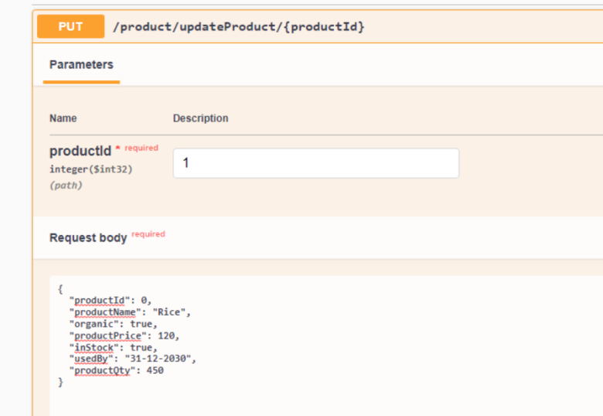

**Response:**

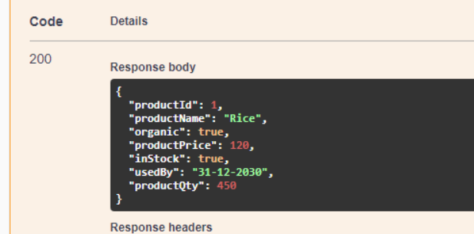

Mailing Service:

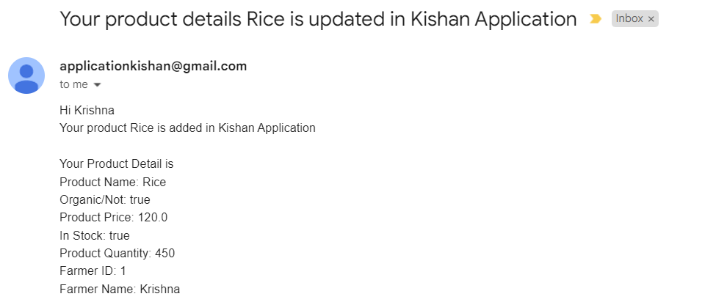

### Module 8: Get All Products

**Source:**

<http://localhost:4001/product/getallProductdetails>

**Request:**

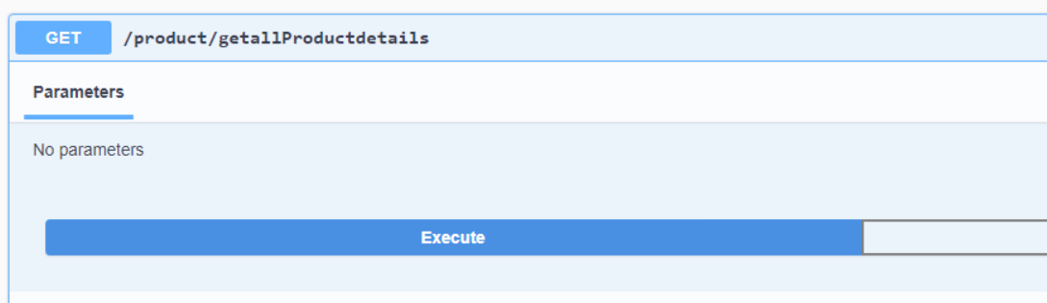

**Response:**

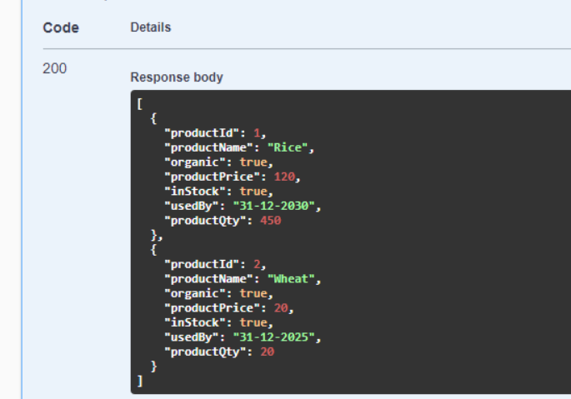

### Module 9: Get Product by Product ID

**Source:**

<http://localhost:4001/product/getProductById/1>

**Request:**

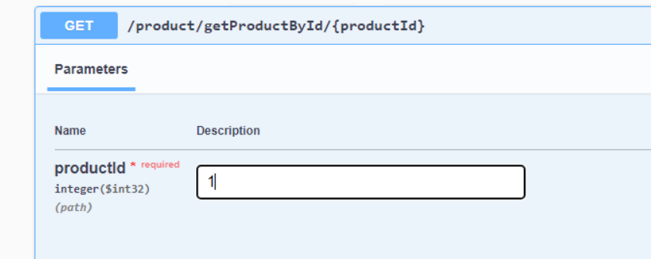

**Response:**

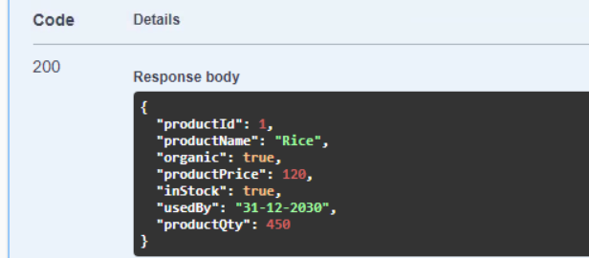

### Module 10: Delete Product by Product ID

**Source:**

<http://localhost:4001/product/deleteproduct/2>

**Request:**

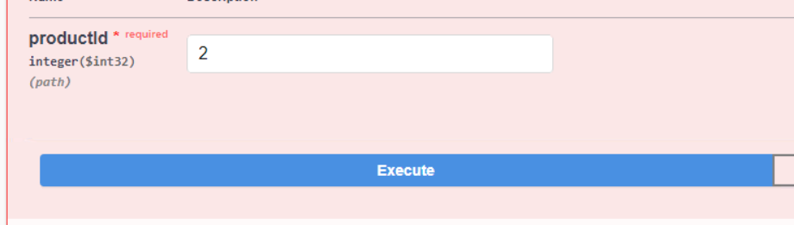

**Response:**

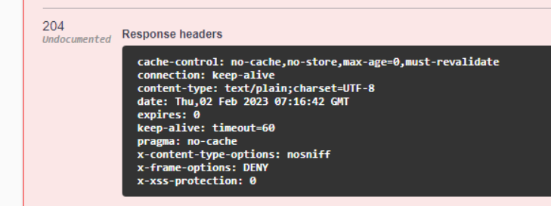

Mailing Service



### Module 11: Customer Registration

Source

<http://localhost:4000/customer/register>

**Request:**

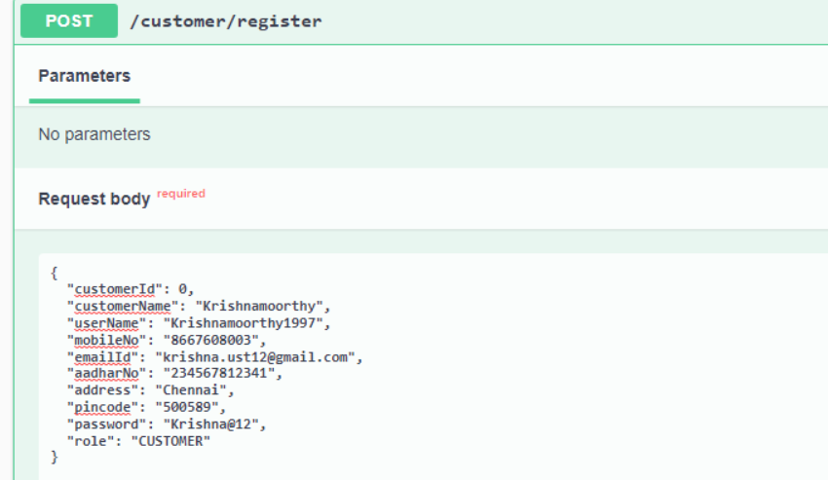

**Response:**

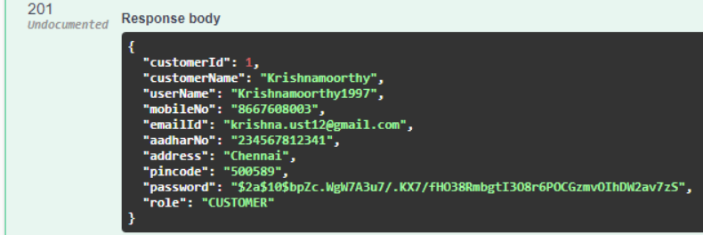

Mailing Service:

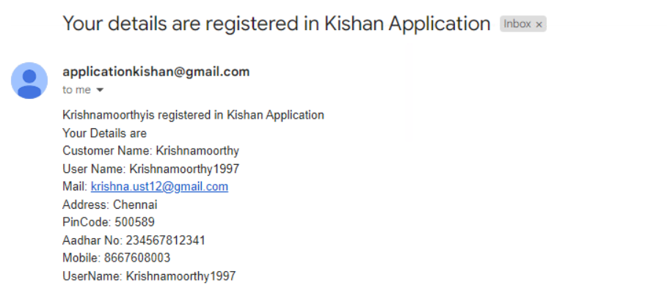

### Module 12: Update Customer Details

**Source:**

<http://localhost:4000/customer/update/1>

**Request:**

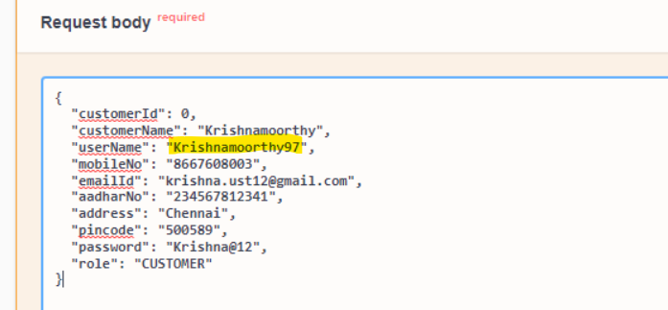

**Response:**

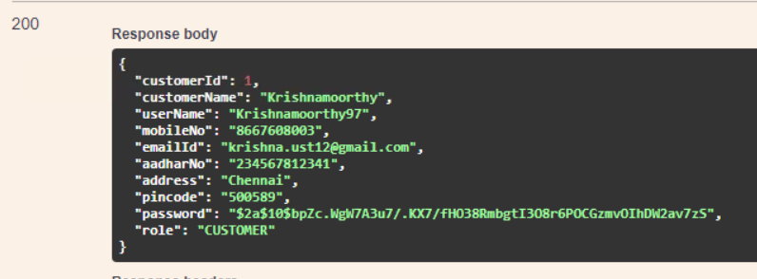

Mailing Service

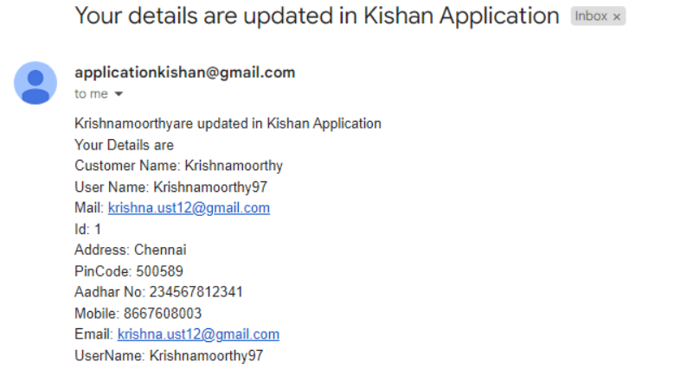

### Module 13: Get All Products from Customer Side(Feign Client)

**Source:**

<http://localhost:4000/customer/product/allproducts>

**Request:**

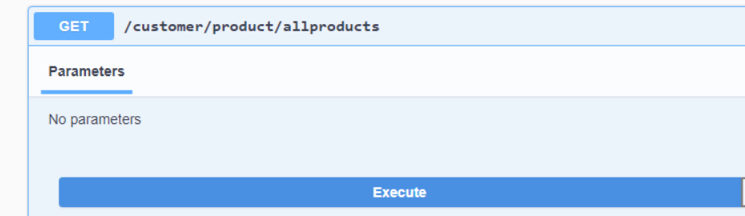

**Response:**

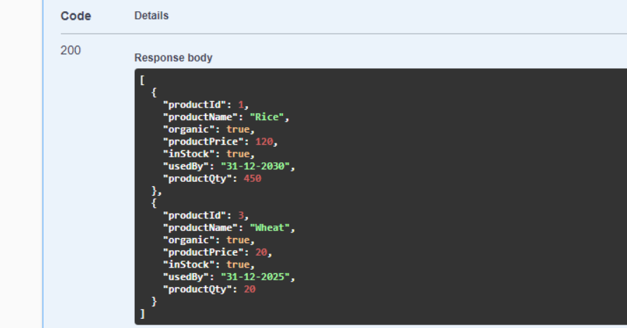

### Module 14: Get Product by Product ID from Customer Side(Feign Client)

**Source:**

<http://localhost:4000/customer/product/getProductById/1>

**Request:**

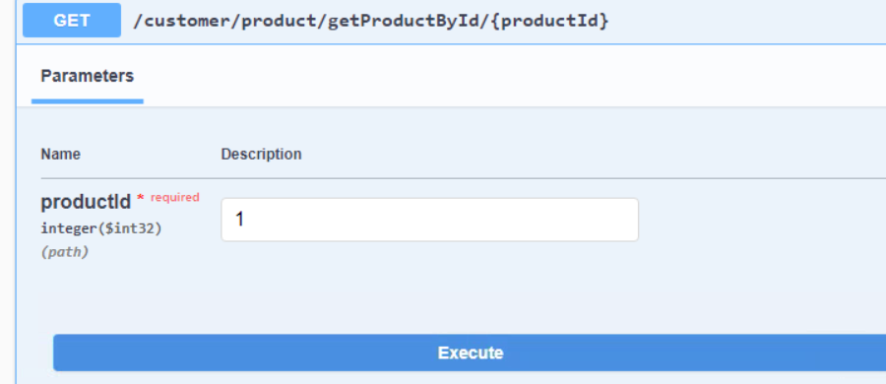

**Response:**

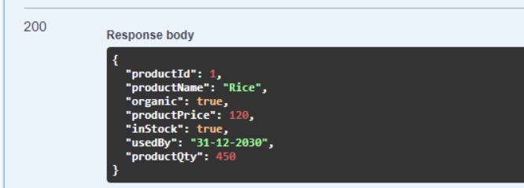

### Module 15: Get All Customer Details

**Source:**

<http://localhost:4000/customer/getallcustomers>

**Request:**

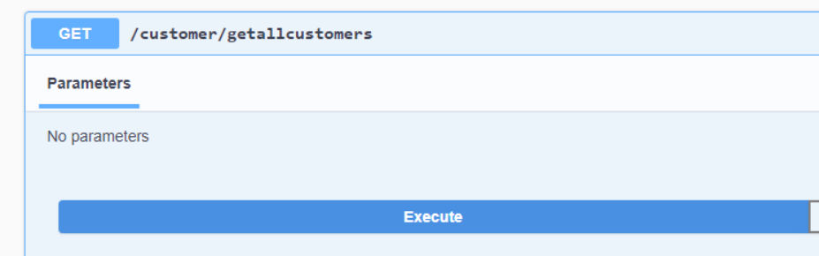

**Response:**

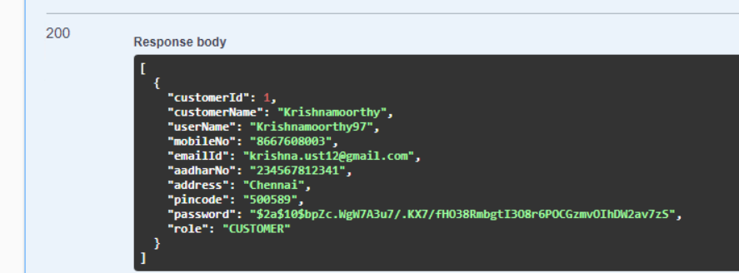

### Module 16: Get Customer Details by customer ID

**Source:**

<http://localhost:4000/customer/getcustomer/1>

**Request:**

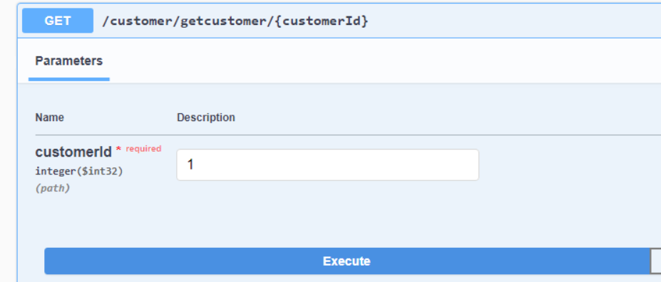

**Response:**

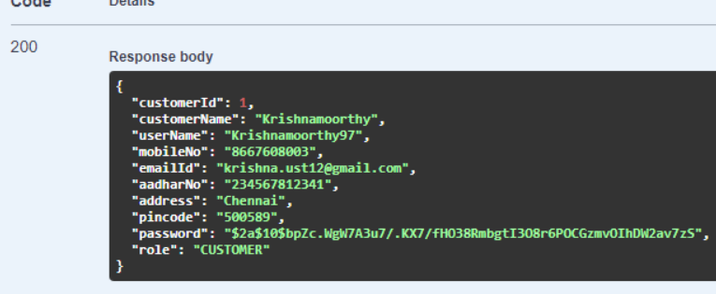

### Module 17: Get Farmer Details from customer by farmer ID (Feign Client)

**Source:**

<http://localhost:4000/customer/farmer/1>

**Request:**

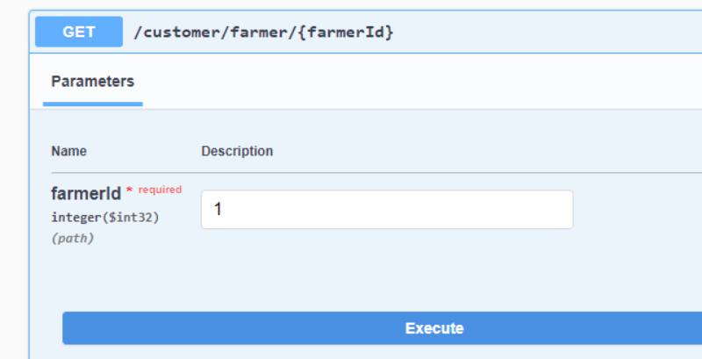

**Response:**

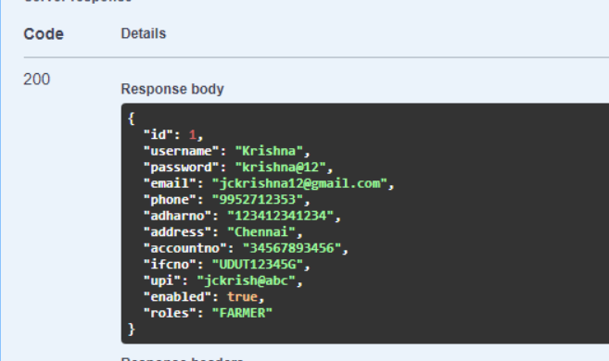

### Module 18: Get Farmer Details from customer by farmer ID (Feign Client)

**Source:**

<http://localhost:4000/customer/farmer/products/1>

**Request:**

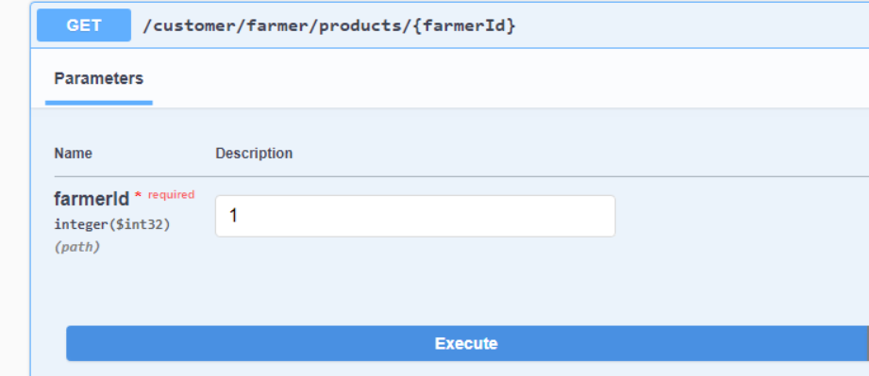

**Response:**

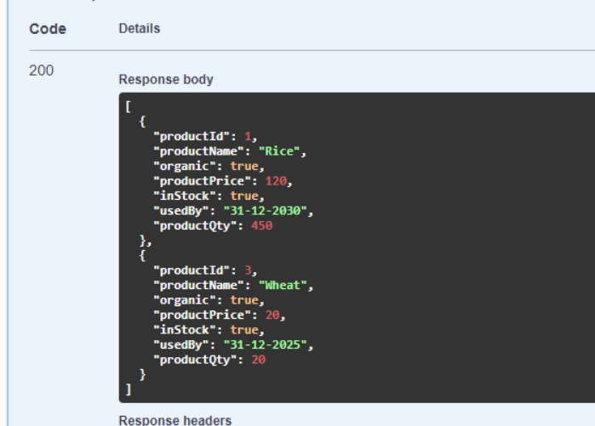

### Module 19: Add to Cart

**Source:**

<http://localhost:4000/customer/addToCart/1/1/1>

**Request:**

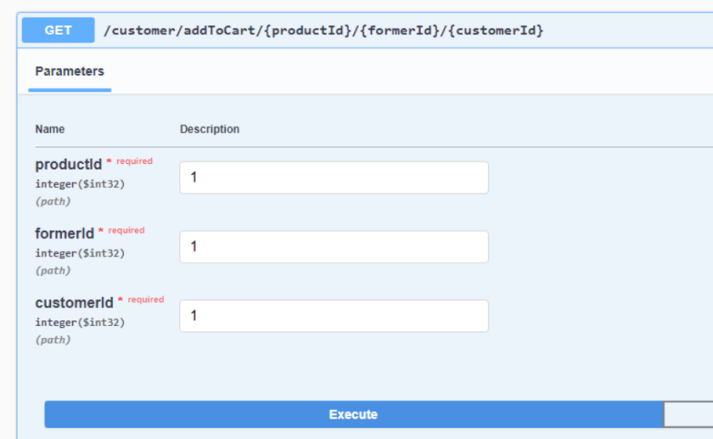

**Response:**

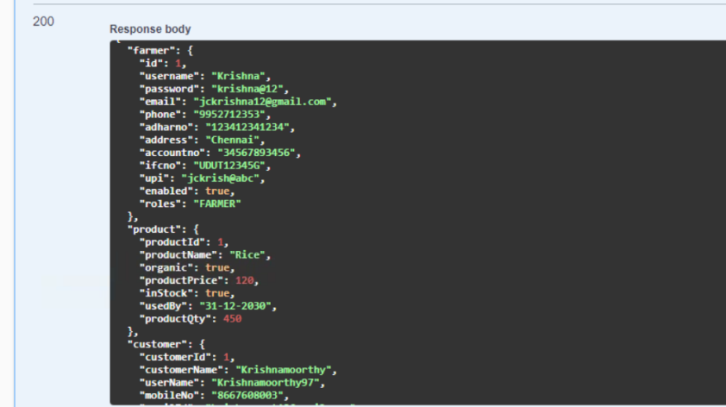

### Module 20: Remove from Cart

**Source:**

<http://localhost:4000/customer/removeFromCart/1>

**Request:**

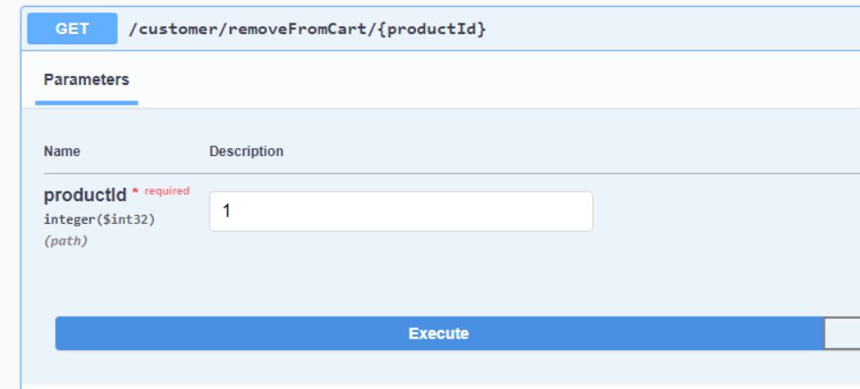

**Response:**

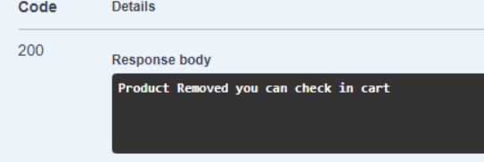

### Module 21: View Cart

**Source:**

<http://localhost:4000/customer/cart>

**Request:**

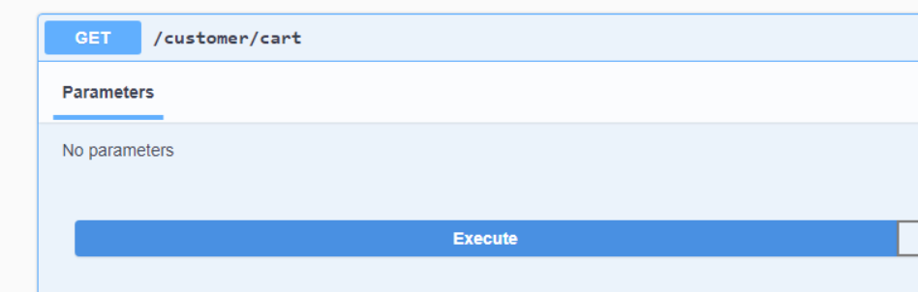

**Response:**

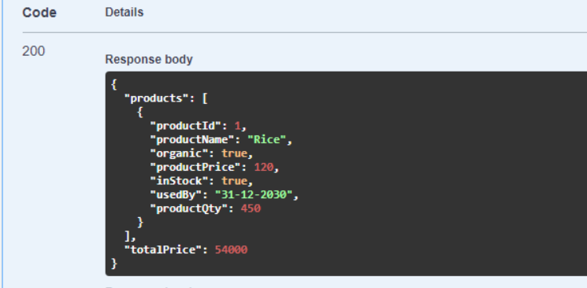

Mailing Service:

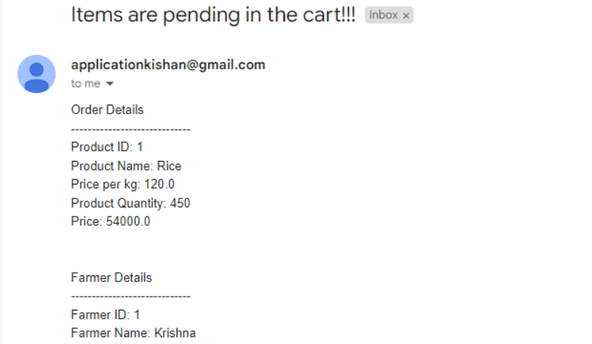

### Module 22: Delete Customer using Customer ID

**Source:**

<http://localhost:4000/customer/delete/1>

**Request:**

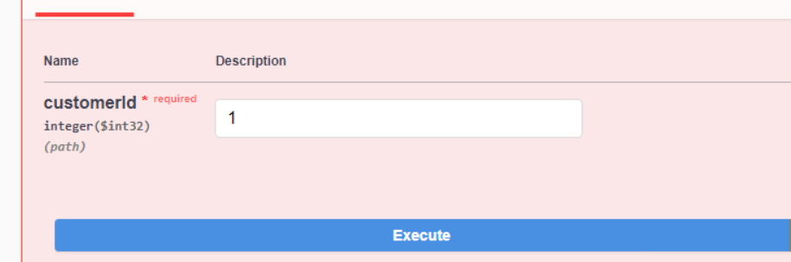

Response:

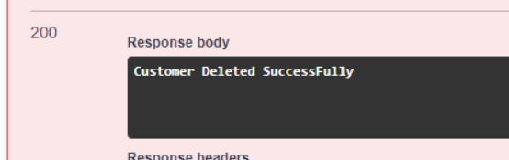

Mailing Service:

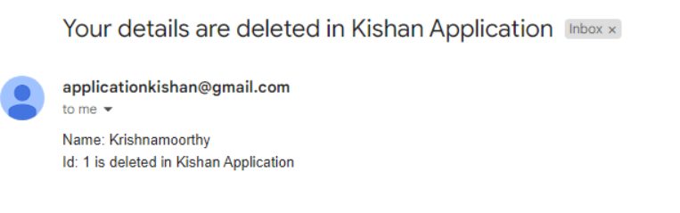

## Benefits

Benefits for Farmers:

1. Farmers can directly connect with customers and sell their produce without intermediaries, increasing their profit margins.
2. KISHAN application provides farmers with a platform to showcase their products and reach a wider customer base.
3. Farmers can better manage their supply and demand, reducing the waste of surplus produce.
4. Farmers can receive fair prices for their produce and avoid exploitation by middlemen.

Benefits for Customers:

1. Customers can purchase fresh produce directly from farmers, ensuring high quality and minimal time between harvesting and consumption
2. Customers can access local produce and support local farmers, reducing the carbon footprint associated with transportation.
3. Customers can see the source of the produce they are purchasing, increasing trust and transparency in the supply chain.
4. Customers can access a wider variety of products and seasonal produce, providing them with more options for their meals.

# Appendices

## Glossary

|  |  |
| --- | --- |
| **Acronyms** | **Definitions** |
|  |  |

## Other

# Terms & Conditions

***Disclaimer: Please do not circulate or distribute this document outside of Cognizant Network, we have a Zero Tolerance Policy. Kindly adhere to 100% Compliance at all times.***

# Change Log

*Please note that this table needs to be maintained even if a Configuration Management tool is used.*

|  |  |  |  |  |
| --- | --- | --- | --- | --- |
| Version Number | Changes made | | | |
| V<n.n> | *<If the change details are not explicitly documented in the table below, reference should be provided here>* | | | |
| Page no | Changed by | Effective date | Changes effected |
|  |  |  |  |
|  |  |  |  |
|  |  |  |  |
|  |  |  |  |